A REPORT ON

Therapeutic Targeting of Misregulated Transcription Factor-DNA Interactions


BITS, PILANI – DUBAI CAMPUS
DIAC, DUBAI, U.A.E.
(Feb 2025 – Jan 2026)

By

Asfiya Tehmeen 2022A9PS0244U

Submitted to:
Prof. Debostuti Ghoshdastidar
Design Project

Table of contents
- Abstract 3
- Problem Statement 3
- Objective 4
- Methodology 4
- Results and Discussions 5
- Future Scope 7
- References 7

Abstract
Transcription factors (TFs), such as members of the E26 transformation-specific (ETS) family, are master regulators of gene expression that function as major oncogenic drivers in many cancers, including acute myeloid leukemia (AML). The structure 1pue is a representative complex of the ETS factor PU.1 bound to DNA. Direct pharmacological disruption of TF-DNA binding is a high-value, yet technically challenging, therapeutic strategy. This project utilizes Molecular Dynamics (MD) simulations to investigate a therapeutic strategy wherein a small molecule, DB293, interferes with the PU.1-DNA interaction. We performed MD simulations and structural analyses on both the 1pue (protein-DNA) and 2i2i (drug-DNA) systems to evaluate the stability, dynamic behavior, and potential binding mode of DB293 at the ETS binding site (EBS). This mechanism offers preliminary justification for developing minor groove binders as a novel class of selective anti-ETS cancer therapeutics.
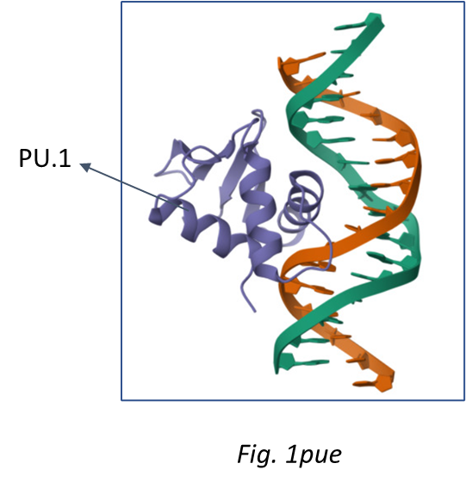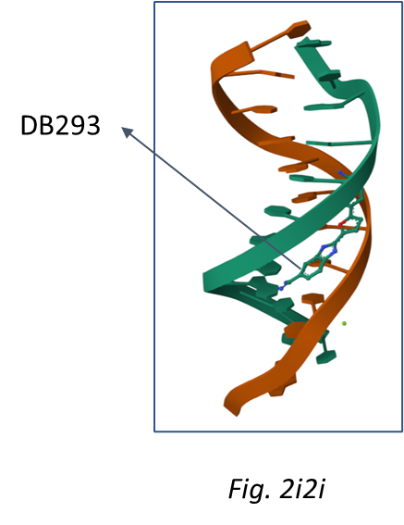

2. Problem Statement
The major challenge in anti-cancer therapy is identifying and drugging TFs, historically deemed "undruggable". Specifically, most TFs, like PU.1 in the 1pue complex, bind the major groove of DNA. The core problem addressed by this study is determining whether a minor groove binding ligand (DB293) can effectively displace or interfere with the binding of a major groove binding transcription factor (PU.1). This competitive inhibition relies on achieving sequence-selective binding and stability of the small molecule complex (2i2i) sufficient to block the recruitment of the ETS domain.

3. Objective
The major challenge in anti-cancer therapy is identifying and drugging TFs, historically deemed "undruggable". Specifically, most TFs, like PU.1 in the 1pue complex, bind the major groove of DNA. The core problem addressed by this study is determining whether a minor groove binding ligand (DB293) can effectively displace or interfere with the binding of a major groove binding transcription factor (PU.1). This competitive inhibition relies on achieving sequence-selective binding and stability of the small molecule complex (2i2i) sufficient to block the recruitment of the ETS domain.

4. Methodology
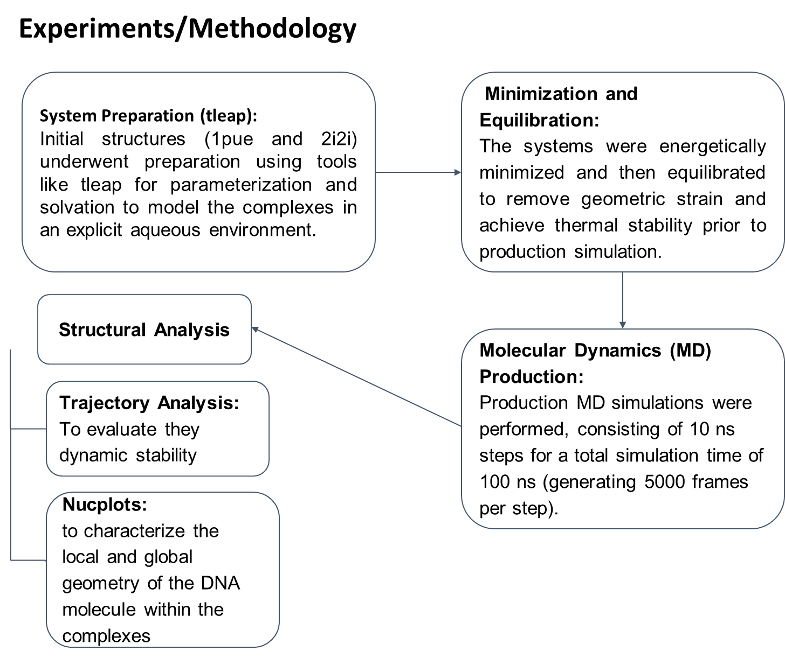

5. Results
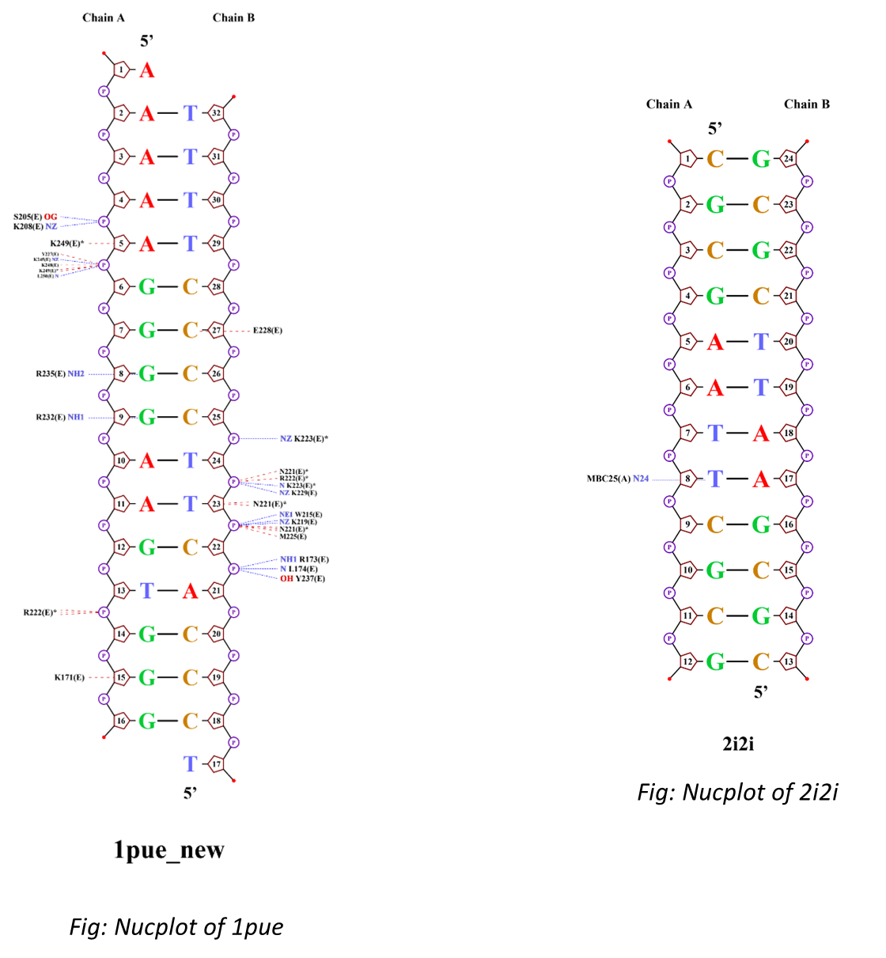

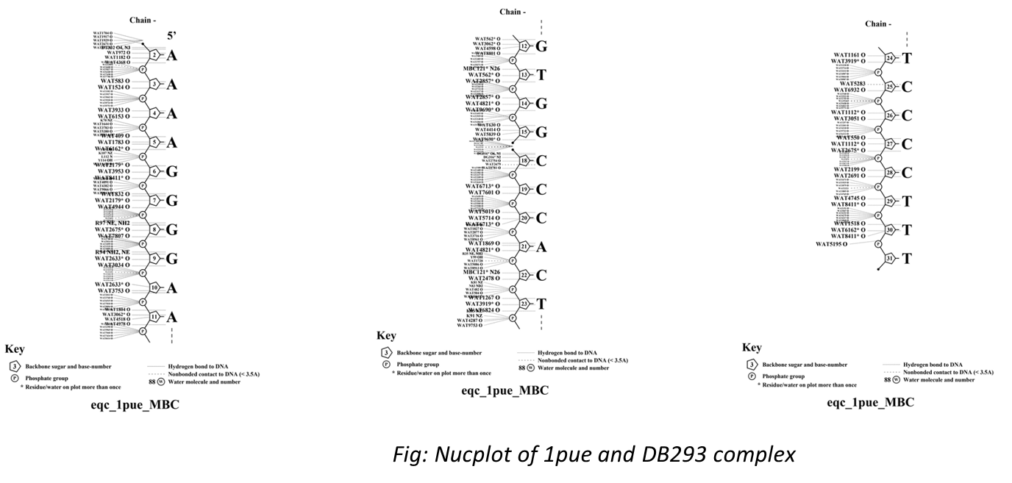
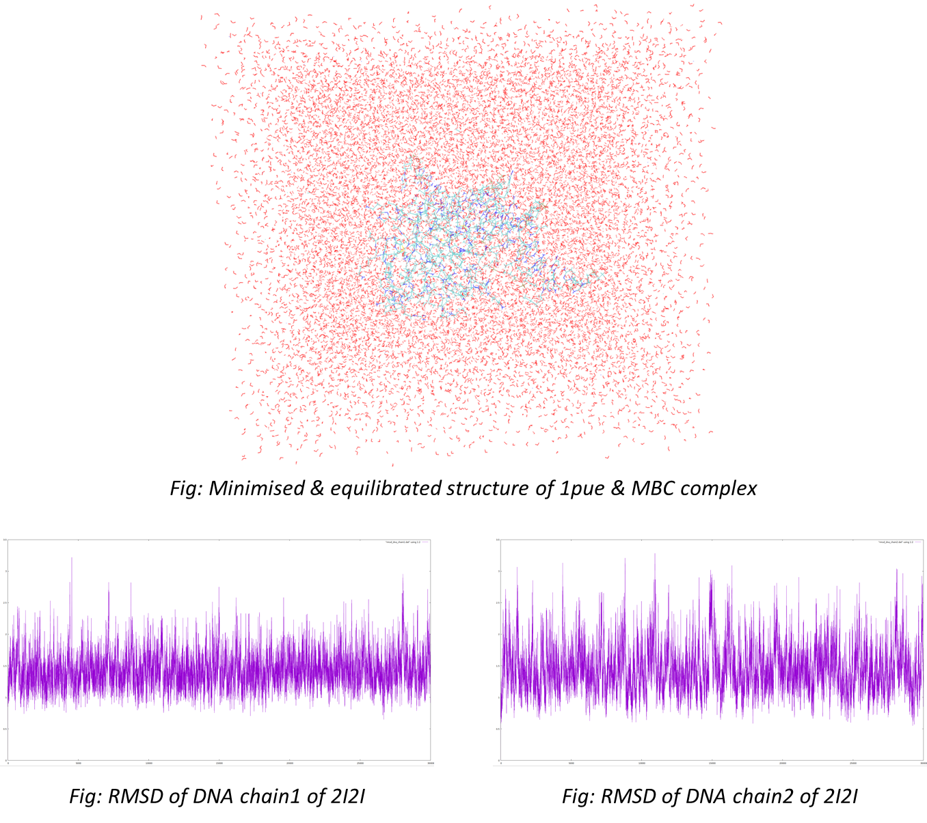
The MD production runs of 1pue and 2i2i provided insight into the solution conformation and long-term stability of the molecular systems over 100 ns. Notably, the simulations of 1pue (protein-DNA structure) resulted in abnormal results, which necessitates a deeper investigation into specific simulation parameters over the trajectory.

DB293 is structurally related to diamidine compounds selected for their ability to bind the minor groove of DNA. The potential of a compound like DB293 to inhibit major groove binders such as PU.1 is supported by the mechanism established for similar compounds (e.g., mithramycin or DB1255 targeting ETS factors). These compounds achieve inhibition either by steric hindrance or allosteric inhibition

The generated nucplots are critical for visualizing these structural effects. For a successful minor groove binder, the nucplots should demonstrate local changes in DNA geometry, potentially showing the widening and shallowing of the minor groove to accommodate the ligand. Comparison of the 1pue and 2i2i nucplots would highlight whether the structural footprint of DB293 on the DNA helix is sufficient to render the PU.1 binding site non-functional.

6. Future Scope
1. Investigate the source of the reported abnormal MD results, possibly by adjusting force fields, increasing equilibration times, or running additional MD replications to ensure convergence to a stable conformation, and refine MD protocols
2. Perform simulations of the ternary complex (DB293 bound to the DNA with the PU.1 ETS domain attempting to bind nearby) to definitively quantify whether DB293 induces steric clashes or allosteric inhibition of the protein's docking site.
3. Use this methodology to screen derivatives of DB293 to identify compounds with enhanced EBS binding affinity and higher therapeutic indices, progressing toward selective anti-ETS cancer drugs.

7. References
[1]M. Hsing, Y. Wang, P. S. Rennie, M. E. Cox, and Artem Cherkasov, “ETS transcription factors as emerging drug targets in cancer,” Medicinal Research Reviews, vol. 40, no. 1, pp. 413–430, Mar. 2019, doi: https://doi.org/10.1002/med.21575.
[2]M. Munde et al., “Structure-dependent inhibition of the ETS-family transcription factor PU.1 by novel heterocyclic diamidines,” Nucleic Acids Research, vol. 42, no. 2, pp. 1379–1390, Oct. 2013, doi: https://doi.org/10.1093/nar/gkt955.
[3]“RCSB PDB,” Rcsb.org. https://www.rcsb.org/
[4]National Library of Medicine, “National center for biotechnology information,” Nih.gov, 2025. https://www.ncbi.nlm.nih.gov/
[5]EMBL-EBI, “Clustal Omega,” Ebi.ac.uk, 2023. https://www.ebi.ac.uk/jdispatcher/msa/clustalo
[6]“AmberTools24,” Ambermd.org, 2024. https://ambermd.org/AmberTools.php

